Table of Contents

Github Repository 2

General Notes:- 2

User Guide 3

TODO 6

# Github Repository

https://github.com/nouraali3/WiresharkNAS.git

# General Notes:-

1. Program is tested on windows 7
2. npf driver should be running
3. I did the project on my own

# User Guide

1-user should choose on of the available interfaces

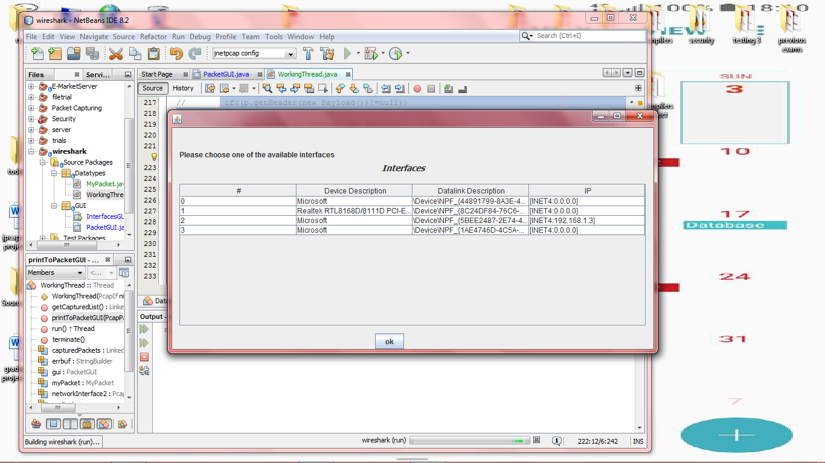

Otherwise, he will be asked to choose one

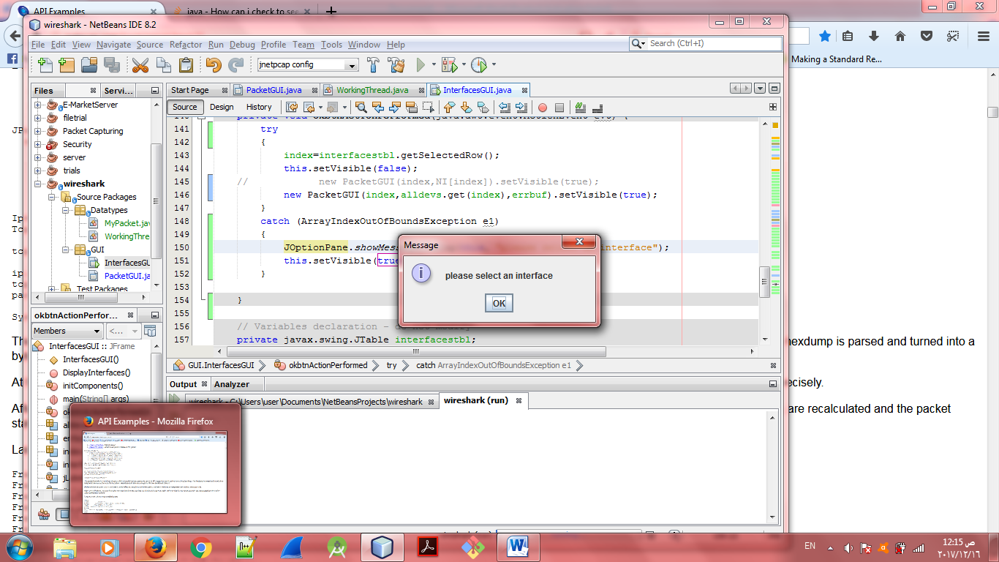

2- a window will appear displaying the interface chosen

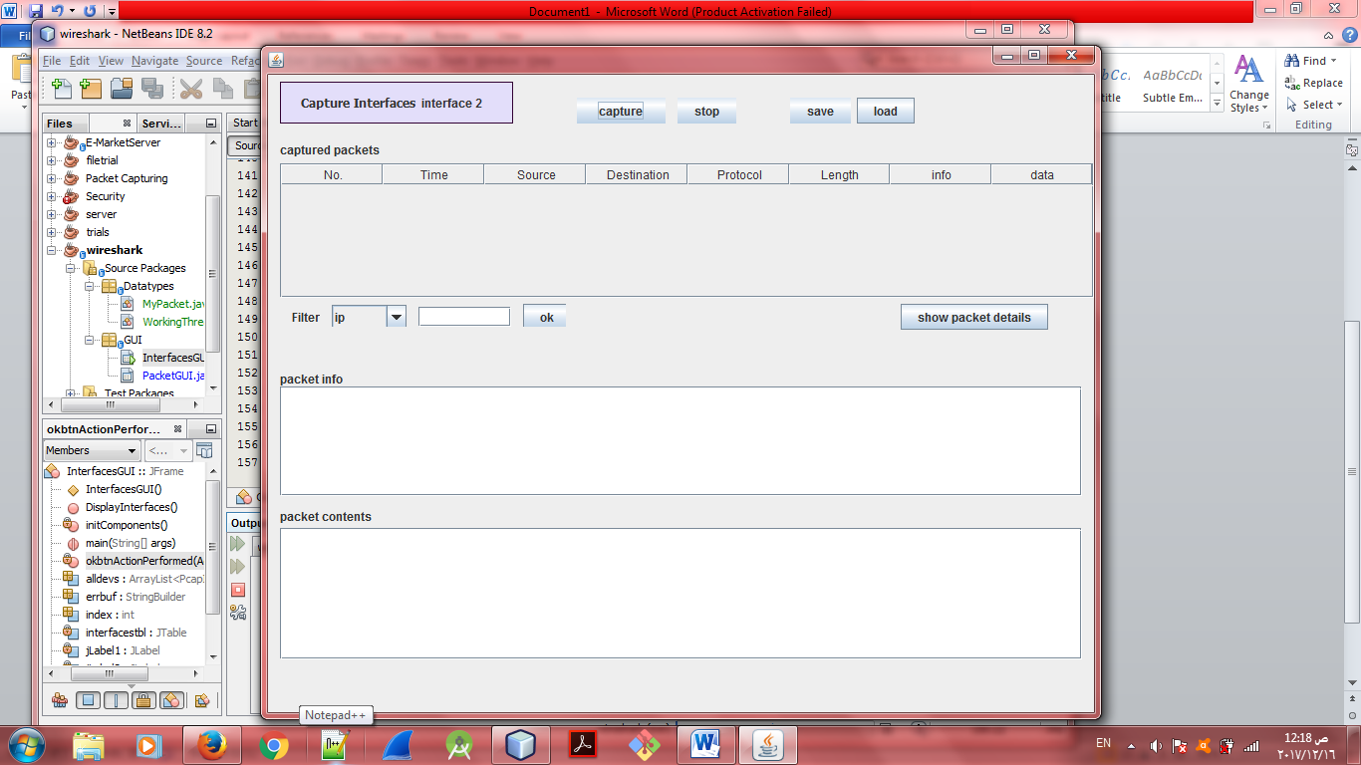

The user has many options

* Capture live packets and the stop whenever he wants to

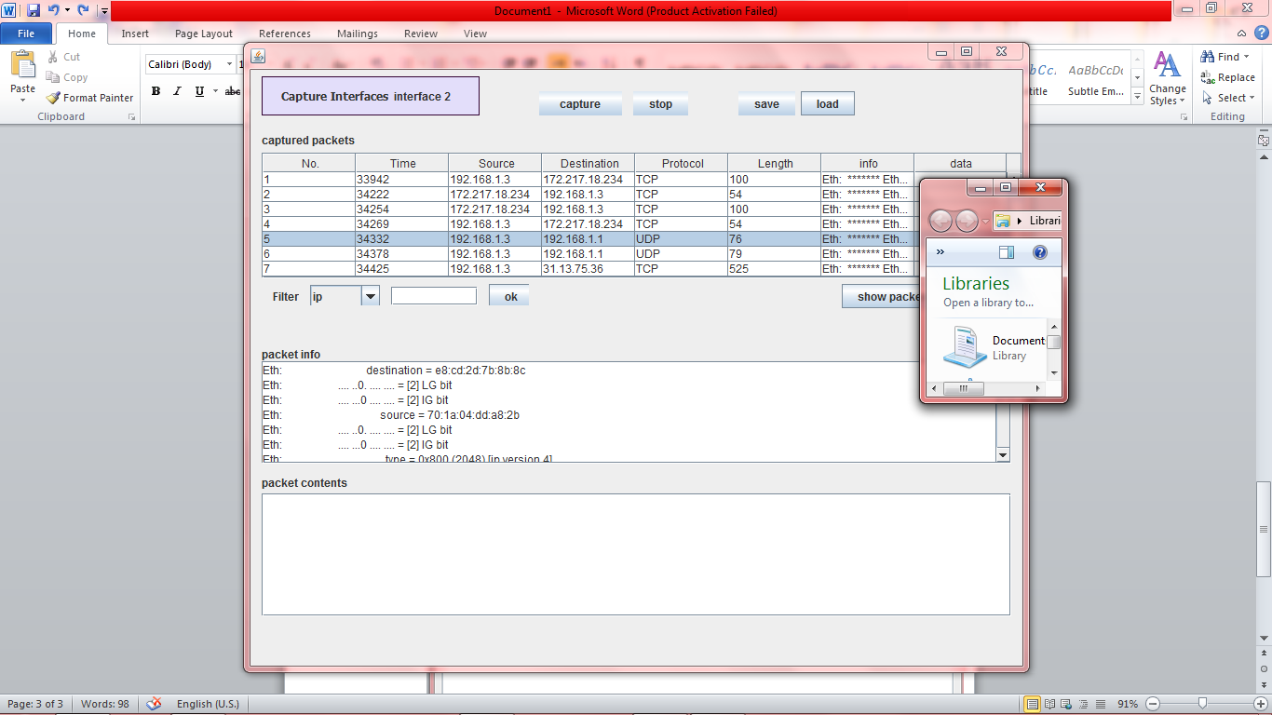

Whenever show packet details is clicked, different protocols displayed such as Ethernet, ARP, TCP, UDP, HTTP

* Filters can be applied on the captured packets from the drop down menu
* Chooses to go back to the list of interfaces by clicking on Capture Interface area

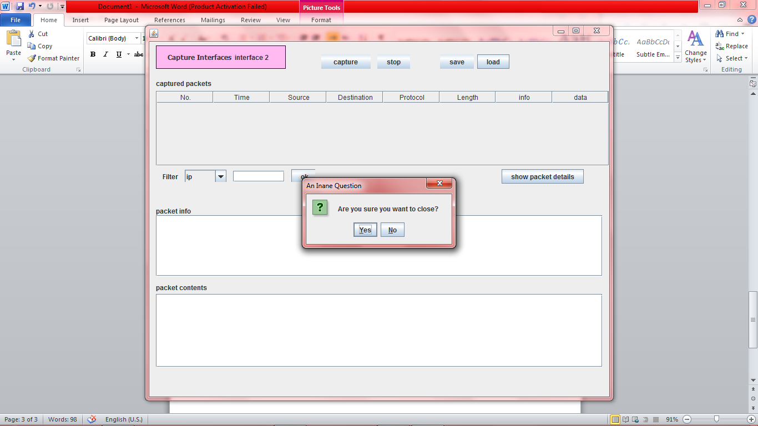

# TODO

* Load a previously captured packed
* Then he has the choice whether to save the captured packets or not